**Image elements do not have [alt] attributes**

May 2, 2019 • Updated Sep 19, 2019

Appears in: [Accessibility audits](https://web.dev/lighthouse-accessibility)

Informative elements should aim for short, descriptive alternate text. Decorative elements can be ignored with an empty alt attribute.

**How the Lighthouse image alternative text audit fails** [**#**](https://web.dev/image-alt/?utm_source=lighthouse&utm_medium=devtools#how-the-lighthouse-image-alternative-text-audit-fails)

Lighthouse flags <img> elements that don't have alt attributes:

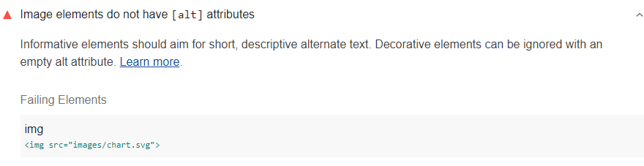

The Lighthouse Accessibility score is a weighted average of all the accessibility audits. See the [Lighthouse accessibility scoring](https://web.dev/accessibility-scoring) post for more information.

**How to add alternative text to images** [**#**](https://web.dev/image-alt/?utm_source=lighthouse&utm_medium=devtools#how-to-add-alternative-text-to-images)

Provide an alt attribute for every <img> element. If the image fails to load, the alt text is used as a placeholder so users have a sense of what the image was trying to convey. (See also [Include text alternatives for images and objects](https://web.dev/labels-and-text-alternatives#include-text-alternatives-for-images-and-objects).)

Most images should have short, descriptive text:

<img alt="Audits set-up in Chrome DevTools" src="...">

If the image acts as decoration and does not provide any useful content, give it an empty alt="" attribute to remove it from the accessibility tree:

<img src="background.png" alt="">

You can also use ARIA labels to describe your images, for example, <img aria-label="Audits set-up in Chrome DevTools" src="..."> See also [Using the aria-label attribute](https://developer.mozilla.org/docs/Web/Accessibility/ARIA/ARIA_Techniques/Using_the_aria-label_attribute) and [Using the aria-labelledby attribute](https://developer.mozilla.org/docs/Web/Accessibility/ARIA/ARIA_Techniques/Using_the_aria-labelledby_attribute).

**Tips for writing effective alt text** [**#**](https://web.dev/image-alt/?utm_source=lighthouse&utm_medium=devtools#tips-for-writing-effective-alt-text)

* alt text should give the intent, purpose, and meaning of the image.
* Blind users should get as much information from alt text as a sighted user gets from the image.
* Avoid non-specific words like "chart", "image", or "diagram".